Unmanned Underwater Vehicle



Watson Capstone Project WCP10

Sponsor: Lockheed Martin

Junle Lu, EE, Team Lead

John Peters, EE

Allie Haltof, CoE

Ben Levine, CoE

Darren Law, ME

Gloria Lee, ME

Faculty Advisor: Professor Timothy Singler

External Advisor: Paul W. Mittan

External Advisor: Matt Ruggieri

May 8th, 2015

Revision: A

Submitted in partial fulfillment of the requirements of ME 493/EECE 487

in the Fall Semester of 2014.

Thomas J. Watson School of Engineering and Applied Science

State University of New York at Binghamton

Table of Contents

Executive Summary 4

1.   Problem Definition 5

1.1. Problem Scope 5

1.2. Technical Review 5

1.3. Design Requirements 5

2.   Design Description 6

2.1.   Overview 6

2.2.   Detailed Description 7

2.2.1.   UUV Structure 9

2.2.2.   Sensors 14

2.2.3.   Ballast System 18

2.2.4.   Propulsion 19

2.2.5. Data Processing and Transmission 21

2.2.6. Power and Operation Time 22

2.2.7. Beacon System 25

2.2.8. Buoy 26

2.3. Use 26

3. Implementation 27

4.   Evaluation 27

4.1. Overview 27

4.2. Testing and Results 27

4.3. Assessment 29

5. Schedule and Budget 30

6.   Next Steps 31

7.   References 31

Appendix A Requirements 31

Appendix B Test Procedures 34

Appendix C Matlab Code 41

Appendix D Creo Drawings and Analysis 45

Appendix E Data sheet links 54

Appendix F Sensor Circuit Diagrams 56

Appendix G Code for UUV control 59

# Executive Summary

**Problem Definition**

The main problem to be solved is to allow an operator to collect data from an underwater environment without having to collect the data themselves. Physically going underwater would expose them to pressure, lack of oxygen, and other various dangers. The operator may also need to locate a certain location underwater that has previously been visited.

**Design Description**

An unmanned underwater vehicle (UUV) is the ideal solution for the problem. The UUV will consist of many subsystems to achieve the goal. One subsystem includes the propellers, motors, and electronic speed controllers to drive the UUV. These will allow for forward movement, stopping, and turning left and right. Another subsystem is the ballast system, which includes the ballast tanks and bilge pumps needed to dynamically change the weight of the UUV; this will allow for ascending and descending. Another subsystem is all the sensors needed to collect the desired data. These sensors include a camera to set up a live feed for navigation so the operator can see where they are going; an IMU, which includes a gyroscope, compass, and accelerometer for UUV orientation information; a depth and pressure sensor; internal and external temperature sensors; and a sonar system to navigate in a low visibility environment. Additionally, there will be a water leak sensor that will act as an emergency shut off should there be a water leak. A beacon system will also be implemented to drop a beacon that can be navigated to at a later point in time. The beacon will be be as simple as dropping an LED.

The UUV itself will be 3D printed as much as possible, with the exception of the internal components and an acrylic dome in front to allow the camera to see outside the UUV. The main frame will be a cylinder to minimize drag force and maximize hydrodynamics. The motors will be mounted on the side of the UUV to maximize water flow. There will be a landing platform mounted on the bottom of the UUV to avoid impact damage from descent.

All the electronic components will be controlled by a BeagleBone Black. The BeagleBone will be able to collect the camera feed, as well as data from the sensors, and transmit it to a ground station laptop via WiFi router. Also, inputs from a keyboard hooked up to the ground station will be able to be sent to the BeagleBone to navigate the UUV by controlling the motors and ballast system. This data transmission is done via a wireless router. The UUV’s BeagleBone will be connected to the router, floating in a buoy on the surface, via an ethernet cable. The router then sends the information from the BeagleBone to the ground station laptop via the laptop’s wireless network card. Note, this processed is simply reversed when sending inputs from the laptop to the UUV.

**Evaluation**

Based on the limited budget and complexity of the project a functional prototype was made; however, not all of the requirements have been met.

# 1.   Problem Definition

## 1.1. Problem Scope

The project will develop and prototype an unmanned underwater vehicle (UUV) that can be controlled remotely and communicated wirelessly to a ground station. The wireless communication will include vehicle control signals, live video streaming, and data from various sensors. The project is sponsored by Lockheed Martin.

## 1.2. Technical Review

While the ocean encompasses 71% of the Earth’s surface, more than 95% of it remains unexplored. The underwater world poses many mysteries that have yet to be uncovered. One way to explore this isolated environment is to utilize an unmanned underwater vehicle. A UUV allows an operator to obtain data underwater without having to physically collect it and avoid being exposed various dangers such as high pressure and lack of oxygen, etc.

There have been many UUVs designed in the past. They have been developed to perform various different tasks such as surveillance, oceanographic data measurements, cable-lying, and many more. The UUVs have been designed by different groups such as academic groups, private companies, and government funded projects. The different UUVs have ranged in size and level of operation from ones that have only operating in laboratories to production models that are widely used. [1]

The main problem that this project will address is the task of collecting data from underwater. This project will allow a person to explore a location using the UUV. This vehicle will transmit a live HD video stream, outside and inside temperature, depth, sonar, water leak sensor, and IMU (inertial measurement units) to the ground station. The operator can drop a beacon at a location of interest, and with this data the UUV or a diver can find the previous location.

## 1.3. Design Requirements

In the UUV design, the focus is on completing five main requirements. The requirements from the sponsor (Lockheed Martin) include speed, depth, operating time, number of sensors, and data collection. All of the requirements are located in Appendix A, and the main requirements are stated in the following list:

1. The speed of the UUV shall be at least 4 knots.

2. The UUV shall travel to a depth of 14 feet.

3. The UUV shall operate at a minimum of 45 minutes on a single battery charge.

4. The UUV shall contain 5 sensors.

5. The ground station shall receive data from the UUV from at least 50 meters away.

Requirement 1 requires the team to research into various propulsion designs able to reach 4.0 knots. Two designs are brushless motor with propellers and pump jets. The trade-off studies shows the motor with propellers design is the best fit and match for the UUV in term of thrust and cost etc. The propeller profile, shape of the submarine, and operating environment have effects on the overall speed of the UUV.

Requirement 2 is a pressure related issue. As the UUV dives into deeper underwater, the surrounding pressure increases. Water leak can occur at high pressures. To determine whether or not the UUV can withstand the pressure at 6 meters, prototype testing and Finite Element Analysis can be used for safety measures. The ballast system with bilge pump is utilized for the UUV to sink.

Requirement 3 presents a limitation to power output of various electronic components. The team performed an operating time study. The study includes current draw, voltage, and maximum input power on each individual electronic part.

Requirement 4 allows the UUV to collect different data such as depth and temperature etc. The data collected by each sensor will prove the overall design has completed all requirements proposed by the sponsor. The sensors will be tested prior to full system integration.

Requirement 5 demonstrates the effectiveness of the WiFi transmission from buoy to ground station. The range of the transmission and data rate will be measured on site during prototype testing.

# 2.   Design Description

## 2.1.   Overview

The UUV is able to explore an underwater environment and collect data, even in low visibility conditions. As shown in Figure 1, the main UUV structure consists of spherical front and a cylindrical body to minimize the drag force. The detailed individual parts can be seen in Appendix C. The size of the UUV is designed to be compact and provide enough space for its internal systems such as ballast system. The cost of 3D printing structure was considered and minimized. The advantages of the 3D printing technology is utilized and the material (PLA) is analyzed to withstand the pressure 14 ft. underwater. The UUV housing is also waterproofed to provide a strong and reliable vessel underwater. Waterproofing will be accomplished by using different grades of sandpaper to even out the layers of the 3D printed parts and coating the parts with acetone to smooth the surface. Epoxy and silicone will be used to assemble the parts in a watertight fashion.

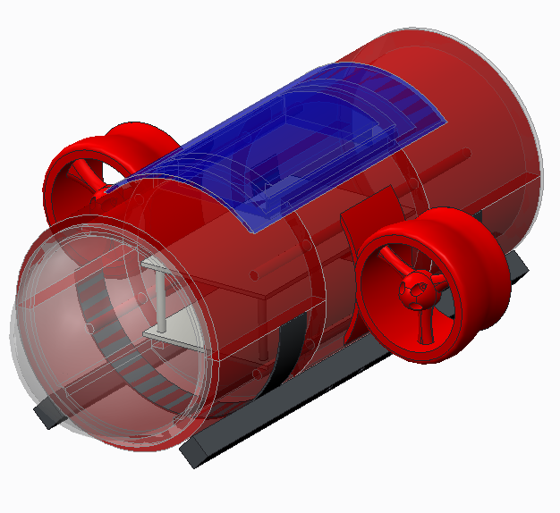

Figure 1. Main Body of UUV

The equipped high quality HD camera provides vision to the operator and it is located inside the transparent acrylic dome as shown in the Figure 1. Various sensors are deployed for navigation and UUV status monitoring. The heat sink, or the first level of the electronics compartment, is located at the bottom of the UUV to dissipate the heat generated by the electronic parts such as batteries, electronic speed controller, etc. The motors with propellers on both sides of the UUV generates enough thrust to achieve the desired speed. The depth of the UUV is controlled by the ballast system which dynamically changes the volume of water inside the UUV. The landing platform is designed to prevent landing impact which may cause damage on the UUV body. A beacon system will be designed and attached to the back of the UUV. Two beacons can be manually dropped and found in a location underwater. All the electronic parts are powered by two LiPo batteries in parallel with sufficient power output and capacity to operate at least 45 minutes.

## 2.2.   Detailed Description

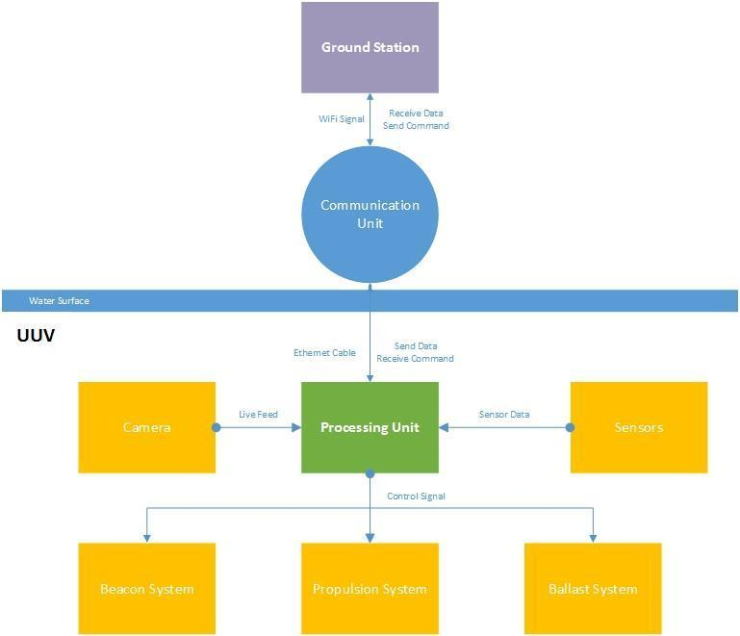

Figure 2. UUV Block Diagram

The UUV communicates and exchanges data with the ground station via a wireless router in a buoy floating on the water. The major systems and connection are shown Figure 2. All the data including the camera live feed is processed and transmitted through the single board computer (BeagleBone Black) via Ethernet cable. The ground station will be simply a laptop with wireless adapter. It receives all the data and displays the live feed source as well as the data from sensors. The operator sends command from the laptop to the processing unit wirelessly. The processing unit generates control signals based the command from the operator along with the inputs from the sensors. The ballast system adjusts the depth of the UUV by dynamically increase or decrease UUV’s weight with bilge pumps. The depth level is maintained autonomously with the feedback from the pressure sensor. The thrust consists of brushless out runner motor and 3-D printed propeller to provide sufficient power to achieve desired speed (4 knots).

## 2.2.1.   UUV Structure

As shown in Appendix C, the frontal area of the UUV is a dome and its body is a cylinder. The design is considered to be a hydrodynamic surface due to the minimization of drag force.

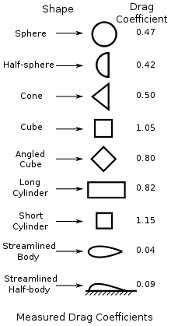

Figure 3. Drag Coefficient of Common Geometries

Acrylic dome is available in sphere shape and it is required for the camera. It has relatively low drag coefficient as shown in Figure 3. The Reynolds number was calculated to determine the actual drag coefficient underwater.

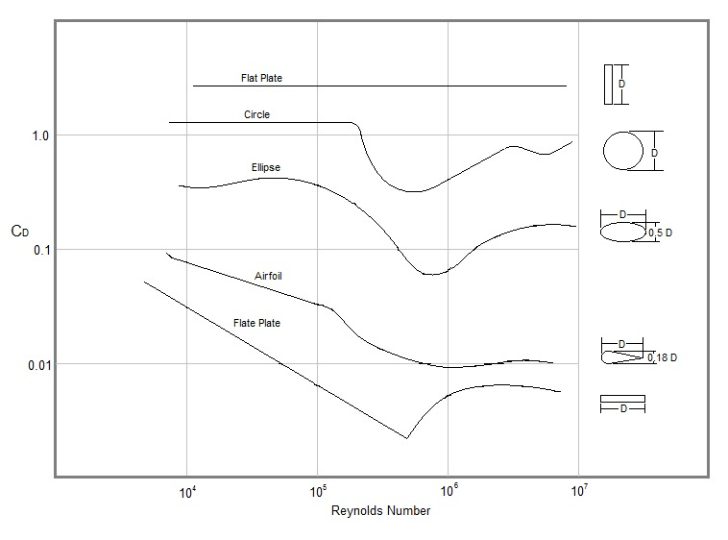

Figure 4. Drag Coefficient Data

Using Equation 1, the Reynolds number can be calculated.



p is the density,  is the diameter of the dome,  is velocity, and  is the fluid viscosity. Density and fluid viscosity are assumed to be 1000 kg/m^3 and 1.004*10^-6 m^2/s, respectively. The diameter of dome is 3.5 inches. Therefore, Reynolds number is 50.1*10^7, and the water flow is determined to be turbulent as shown in Figure 6.

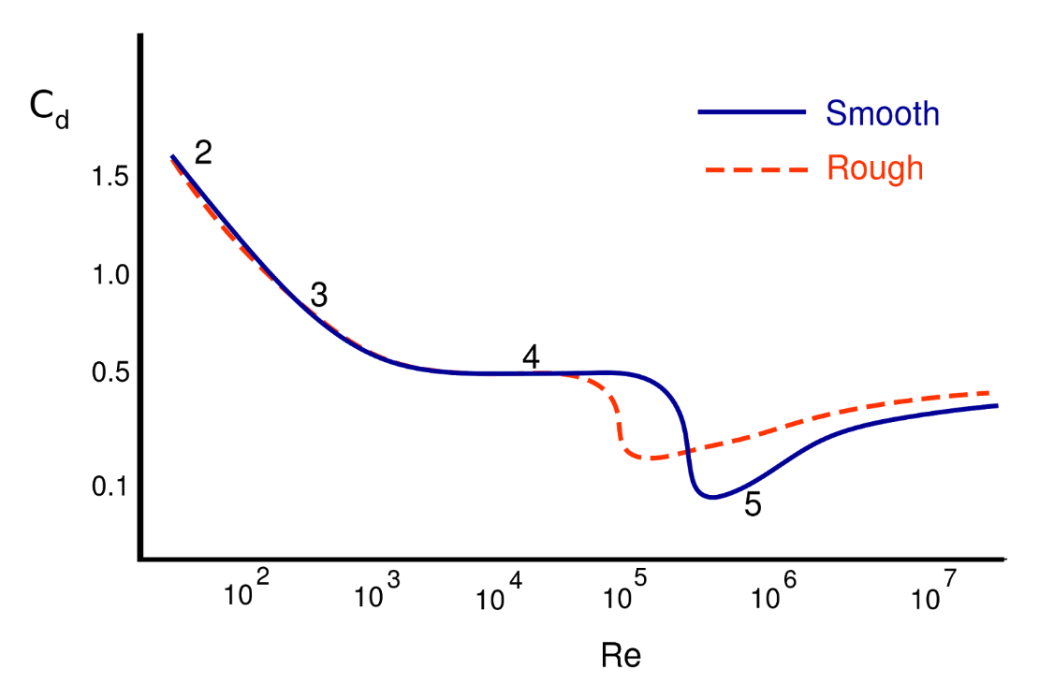

Figure 5. Drag Coefficient Data for Spherical Surface

The correlated drag coefficient is determined from the calculated Reynolds number as shown in Figure 5. The frontal dome is made of acrylic with smooth surface. The drag coefficient is estimated to be 0.3.

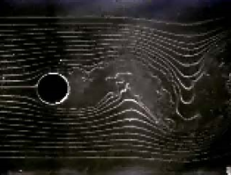

Figure 6. Turbulent Flow Profile for a Sphere

The weight of the UUV depends on amount of buoyancy force needs to counter to just submerge underwater. The increasing size of the UUV results stronger total buoyancy force acting upon the UUV. Therefore, the size of the UUV is designed to be compact to minimize the weight of UUV and reduce the load on thrusters. The dimension of all internals components were determined and the total length of the UUV is determined to be 18.5 inches to encase all the internal systems.

The electronic compartment was designed to place and protect the electronic parts. The compartment consists of two levels. The bottom level is for the batteries, while the top level is for other electronics as shown in Figure 7.

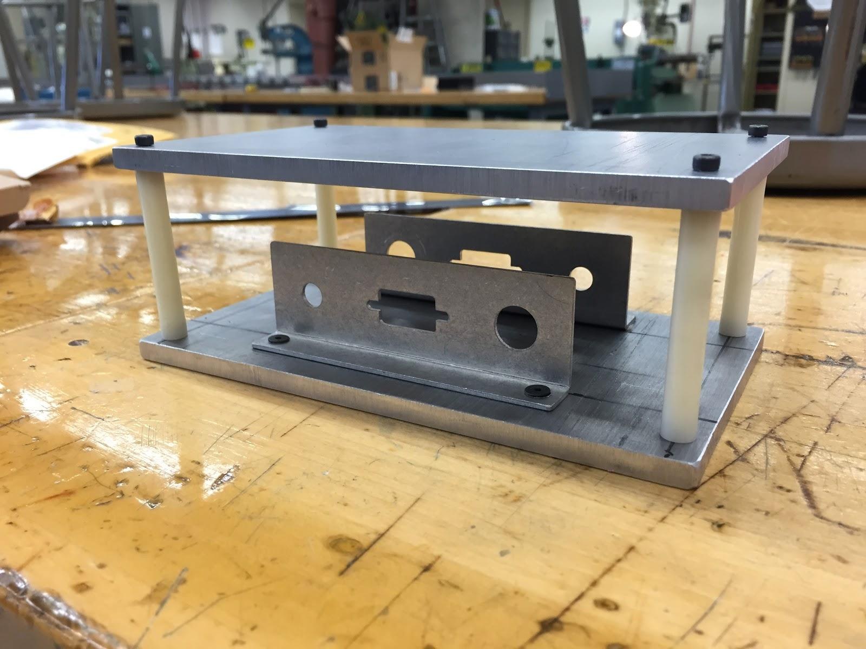

Figure 7. Electronics Compartment

The length of the compartment is 7 inches, and the width is 4.28 inches. The compartment provides adequate space for all electronics.

The UUV has two collapsible water containers, and each water container connects to two bilge pumps. The containers will be used to change the weight of the UUV so that buoyancy can be manipulated. The current weight of the UUV, without any water in the ballast system, is 10.18 kg. Each part was either manufactured or purchased, and the weights were determined by using a scale. These weight values can be seen in Table 1.

|  |  |  |  |  |
| --- | --- | --- | --- | --- |
| **Parts** | **Material** | **Weight (g)** | **Number of parts** | **Total Weight (g)** |
| **Cylindrical Body** | PLA | 1709 | 1 | 1709 |
| **Cap** | Acrylic | TBD | 1 | TBD |
| **Dome** | Acrylic | 174 | 1 | 174 |
| **Hatch with Gasket** | Aluminum & Rubber | TBD | 1 | TBD |
| **Electronic Compartment** | Aluminum | 656 | 1 | 656 |
| **Nozzle** | PLA | 122 | 2 | 244 |
| **Propeller** | PLA | 25 | 2 | 50 |
| **Landing Gear** | Steel | 10000 | 1 | 10000 |
| **Stand-Off Rods** | Plastic | 6 | 6 | 36 |
| **Battery** | N/A | 346 | 2 | 692 |
| **Camera** | N/A | 25 | 1 | 25 |
| **Motor** | N/A | 66 | 2 | 132 |
| **Pump** | N/A | 61 | 2 | 122 |
| **ESC** | N/A | 34 | 2 | 68 |
| **Water Container** | Plastic | 100 | 2 | 200 |
| **BeagleBone Black** | N/A | 41 | 1 | 41 |
| **Miscellaneous Electronics** | N/A | 300 | N/A | 300 |

Table 1. Weight Analysis of UUV

PLA has a higher density and greater part accuracy than Acrylonitrile Butadiene Styrene (ABS). ABS is a stronger material, but there is a greater difficulty in 3D printing. Ballast tanks scaled ⅛ in size were printed as prototypes for comparison. Figure 8 shows that the tank printed in PLA has a higher accuracy and cleaner finish.The material property of PLA is summarized in Table 2.

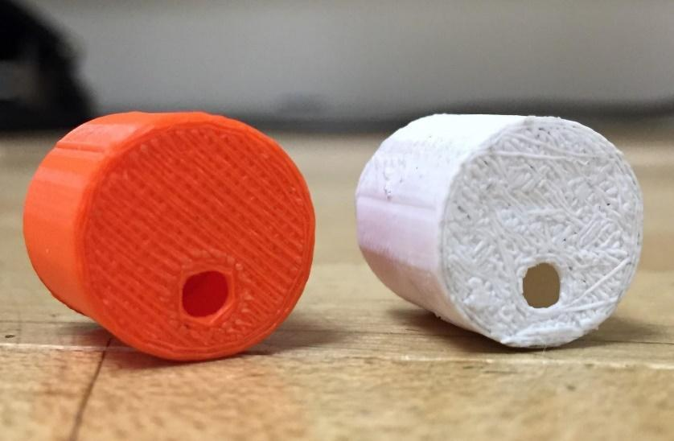

Figure 8. Material Comparison: PLA (left) vs. ABS (right)

|  |  |
| --- | --- |
| Density | 1.24 g/cm^3 |
| Type | Brittle |
| Water Solubility | Insoluble |
| Tensile Strength | 57.8 MPa |
| Tensile Modulus | 3.3 GPa |
| Melting Temperature | 175 ℃ |
| Heat Resistant | 110℃ |

Table 2. Material Property of PLA

The cylindrical body of UUV must be able to withstand the hydrostatic pressure at 6 meters underwater. The total pressure at 6 meter can be calculated by using equation 2.



is the total pressure, is the atmosphere pressure,  is the density, g is gravity due to acceleration, and h is the depth of the water. The atmosphere pressure is 101325 Pa. The density of water is 1000 kg/m^3. g is 9.81m/s^2, and the depth of the water is 6 m. The total pressure is calculated to be 160185 Pa. This calculation was also done in MATLAB; the code can be seen in Appendix A. In Table 2, the tensile strength of the material is significantly greater than total pressure. Therefore, a thickness of 0.5 inch for the UUV’s cylindrical body is considered as a safe assumption. Finite Element Analysis (FEA) was performed to show the stress over a region and to justify the assumption. Appendix C displays the FEA results for two different thickness--0.2 and 0.5 inches--as a comparison.

## 2.2.2.   Sensors

The sensors are critical to the UUV’s operation; they include an inertial measurement unit (IMU), sonar, and temperature, pressure, and water leak sensors. These will all be connected to the BeagleBone via electrical jumper cables.

The IMU includes an accelerometer, gyroscope, and compass. These will be essential for navigation as it gives the orientation of the UUV. The feedback from the IMU is input into a control algorithm for better stability of the UUV underwater. For instance, if the UUV is experiencing unexpected water current and the pitch is forced downward, the change in UUV’s orientation is detected by the IMU. The pitch control algorithm will be triggered to counter the current and restore its desired orientation. Orientation and pressure data will be obtained by a commercially available breakout board that combines an MPU-9250 IMU and MS5637 pressure sensor. The MPU-9250 features an I2C output of its 9-axis (each axis being 16-bits) orientation via its SDA port at an SCL frequency of 400 kHz. It also contains an auxiliary I2C port, which allows coupling of the MS5637’s 12-bit pressure reading (between 10 - 2000 mBar) to a single I2C port to the BeagleBone as seen in Appendix F1. The pressure sensor can give us a good indication whether there is a leak considering it monitors the UUV’s internal pressure. Since both components require a 2.4V-3.6V supply voltage, they can be powered by the BeagleBone’s 3.3 V port, which will also be used to pull-up the SDA/SCL data signals. The data signal and the single interrupt pin on the breakout board will be connected to 3 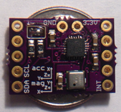separate GPIO pins on the BeagleBone, as seen in Appendix F.1.

Figure 9. IMU/Pressure Sensor Breakout Board

An external pressure sensor will also be utilized on the UUV to determine the depth. A MS5541C pressure sensor module accomplishes this, as it has a range from 0-14bar (20ft underwater translates to 0.5978bar) and comes with a waterproof membrane. This pressure sensor also contains a temperature sensor, which can be used to obtain the water temperature considering the sensor interfaces directly with the outside environment to obtain its pressure measurements. The module requires a 32.768 kHz clock signal, which is being provided with an external oscillator. These components are connected to a proto-board, as shown in Figure 10, which will then communicate with the UUV’s processor via an SPI interface.

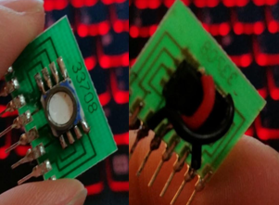

Figure 10. External Pressure Sensor Module

The sonar transducer selected has an 8.4 degree cone angle and is rated for 100W. The circuit pulsing it in order to receive a distance measurement is shown in Figure 10, with a more detailed one in Appendix F.2. The circuit was first tested on an inexpensive 40 kHz transducer (needing some adjustments in the circuit to account for the frequency change) as proof of concept. Testing is still in progress on the circuit, but if this does not end up working we have the option to buy a depth sounder, but it will be significantly more expensive.

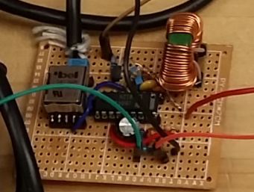

Figure 10. Sonar Circuit on Perforated Circuit Board

Multiple temperature sensors will monitor the temperature inside the UUV, which will allow us to be certain that the various electronic components (batteries, motor controllers, processor, etc.) that generate a significant amount of heat are thermally managed. These real time temperature readings will be necessary to ensure safe operation of the UUV. The temperature sensors we will use are DS18B20 sensors, which are inexpensive and already come waterproofed. The internal sensor will be mounted on the wall of the UUV above the electrical compartment with electrical tape. The external temperature sensor will be mounted externally onto the sonar transducer, with the wire being fed through the same hole as the transducer’s wiring. They will require a 3V-4.0V supply voltage, which will be connected to the BeagleBone’s 3.3 Vpin. The data pin will also be pulled up by this voltage supply, and will give a 9 - 12 bit resolution temperature reading between -55°C to +125°C. The sacrifice for resolution is time taken to convert temperature to a digital reading, which we will have to do testing on to see which is most appropriate. The DS18B20 not only utilizes a single data pin, but can obtain data from multiple temperature sensors on a single data wire due to them each having unique serial numbers, as seen in Appendix F.3.

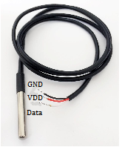

Figure 11. DS18B20 Temperature Sensor

The water leak sensors will ensure that the UUV’s housing remains watertight during operation so that in the event that it does fail, there is time to rescue and protect the electronic components of the UUV. The water leak sensors will consist of a simple circuit, which can be found in Appendix F.4. They will send a digital high (3.3V) to the BeagleBone when there is no water present. When water is present, the circuit will be complete and the connection to the BeagleBone GPIO pin will be grounded, therefore low. The probes consist of two stranded together wires stripped of insulation at arbitrary locations, seen in Figure 12, to allow conduction when in contact with water. The wire will be placed at the bottom-most part of the UUV for the best chance of detecting water. We will have to do some testing as to the optimal resistor to use in the circuit for use in different water environments (based on contaminants and purity).

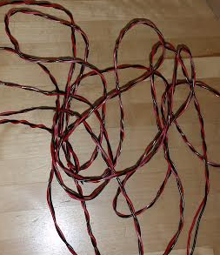

Figure 12. Water Leak Sensing Wire

When the water triggers this circuit, a digital high can be sent to battery protection circuit (Appendix F.5), which will prevent the positive terminal from the batteries from contacting the water. The use of silicone to pot this circuit, shown in Figure 13, also prevents the possibility of the batteries’ positive terminal from contact with the water.

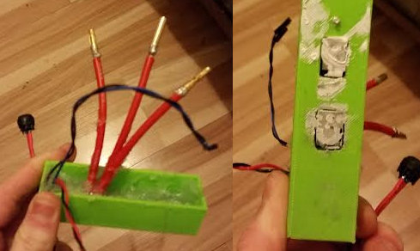

Figure 13. Battery Protection Circuit Case

## 2.2.3.   Ballast System

The ballast system is designed to control the depth of the UUV underwater. It includes two water pumps and two collapsible containers as shown in Figure 14. They are placed in the front and back of the UUV. The pitch of the UUV is controlled by shifting the center of mass with the ballast system. The water pump water flow rate is controlled by H-bridges. The depth of the UUV can be controlled by the operator and autonomously maintains the depth level with the feedback from the pressure sensor.

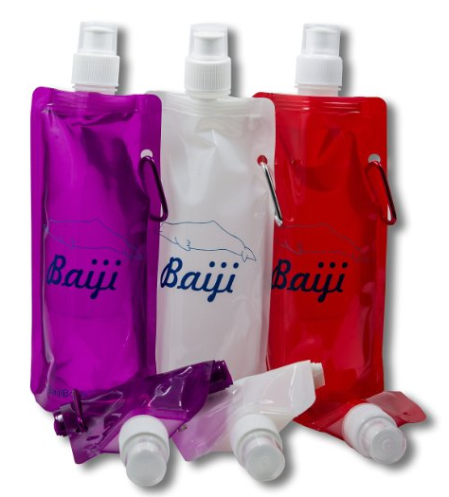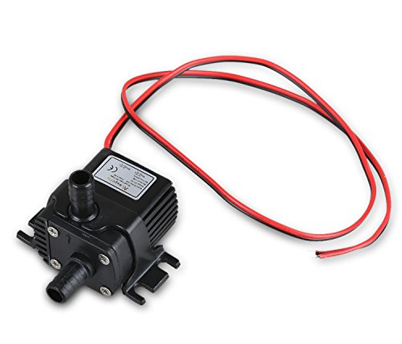

Figure 14. Components of Ballast System

## 2.2.4.   Propulsion

The UUV is required to have a maximum speed at least 4.0 knots or 2.06 m/s.  The drag force of the UUV at 4 knots is calculated by Equation 3 below.

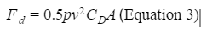

P is density 1000 kg/m^3; v is velocity; CD is drag coefficient 1.2; A is frontal area 0.025 m^2. The calculated drag force is 14.65 N, which is the minimum thrust required to reach 4.0 knots. The thruster consists of a brushless out-runner motor, an electronic speed controller (ESC), and 3D-printed propellers and nozzles. The brushless motor provides more power and higher efficiency than brushed DC motors. A brushless motor has two distinct type of motors: in-runner and out-runner. An in-runner motor is typical for high RPM applications such as a speed boat. The weight of the UUV and water resistance requires the motor to produce enough torque at low RPM. The brushless out-runner produces higher torque and efficiency at low RPM with low Kv rating.

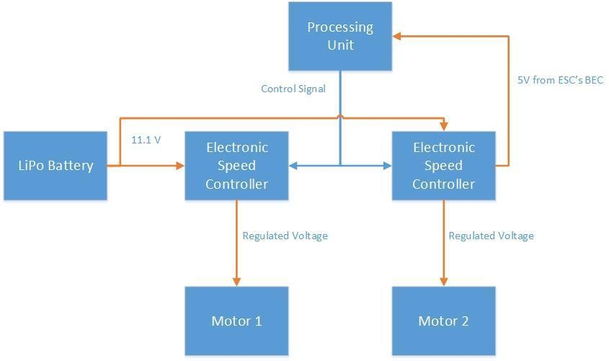

Figure 15. Thruster Block Diagram

An electronic speed controller will be attached to each motor to regulate the speed as shown in Figure 15. The connections and wiring are simple and straightforward. The BeagleBone will send information received from the keyboard to start and stop the motors, as well as adjusting the speed. The individual motor speed can be controlled to make turns by creating imbalance forces from the two motors on the sides. The motor operates underwater naturally. The stator and magnets are coated with CorrosionX HD to prevent the rusting problem. The propellers and nozzles have been created on Creo and 3D printed. These prints can be seen in Figures 16 and 17.

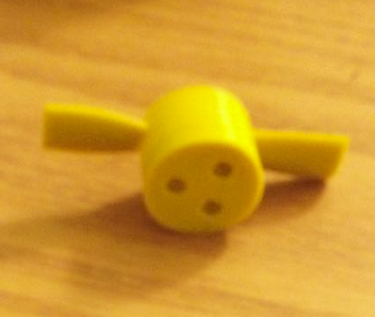

Figure 16. 3D Printed Propeller

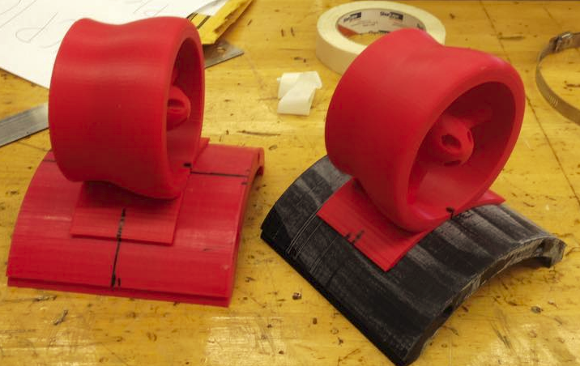

Figure 17. 3D Printed Nozzle

NTM Prop Drive Series 2836 750kv was chosen because the useful testing data was available as shown in Figure 18.

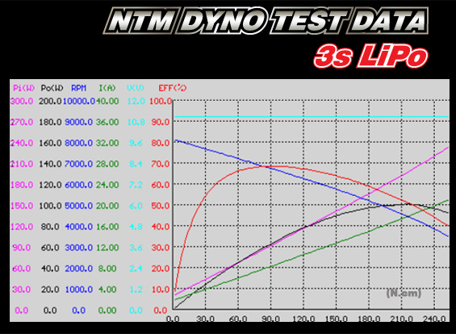

Figure 18. NTM Dyno Test Data

The propeller was designed by using the propeller design software OpenProp as reference, which is an open source program developed by Massachusetts Institute of Technology (MIT) since 2001. The design tool is based on moderately-loaded line lifting line theory, which is used in parametric design codes employed by the U.S Navy, as well as commercial designers. The weight of the UUV and the desired speed will affect the profile of the propeller such as pitch and diameter etc. The propeller was modeled and the dimension was matched with the motor’s power output for the desired thruster. The 3D CAD file could not be generated by the OpenProp, so the propeller was modeled in Creo.

## 2.2.5. Data Processing and Transmission

All the data including HD camera is processed by a single board computer BeagleBone Black. The router in the buoy establish the connection between the UUV and ground station. The BeagleBone is physically connected to the router with Ethernet cable while the ground station unitized the WiFi signal transmitted by the router which supports at least 50m range of communication.

The BeagleBone black will control the movement of the UUV. Appendix C contains the code for the control of the UUV written in C. When a key on the laptop is pressed the UUV will execute the corresponding motion. There are two integers that are the speed values for the two motors. The speed of the motors can be between 800,000 and 2,000,000. With the speed of 800,000 corresponding to no movement. One can increase or decrease the speed of both motors at the same time by 10,000 by pressing the up or down arrow keys. An increase or decrease of 10,000 is approximately equal to 0.833% of the total speed. The keys 0 through 9 allow one to quickly change the speed of both motors. Key 0 makes the motors 0% of total speed or 80,000, key 1 10% of total speed or 83,000, following that pattern till key 9 at 90% or 1,870,000. The space bar turns both of the motors off. The f key is used to go forward and will set the motors to equal speeds. To turn the left and right arrow keys are used. To turn right the right motor is turned off and the left motor stays the speed it was before. The same concept is used for turning left. The BeagleBone black has 8 PWM pins that can be set up. To control the speed of the motors the duty cycle of the pins are modified.

A link to the BeagleBone black’s data sheet is in Appendix D. The BeagleBone has a USB port that the HD camera will be plugged into. There is also an Ethernet port on the BeagleBone where the Ethernet cable to transmit the data to the router will be connected. The BeagleBone has an input power of five volts.

The camera that is being used it the Logitech C920 HD webcam. This web camera uses full HD 1080p video streaming with built in H.264 compression. The camera also has auto focus feature. A live stream from the camera will be visible on the ground station using MJPEG streamer.

Data transmission is accomplished mainly by a wireless router. The router that we are going to use is the TL-WR841N router. A link to the routers data sheet is in Appendix D. The router is capable of transmitting over 50 meters, which is the distance needed to reach the ground station. It can transmit up to 300 megabits per second, which is a large enough data rate to send all the necessary data. The router is a class N router that transmits at 2.4 GHz. The router is powered by 9V. A wire from the UUV’s battery will power the router. The router has four LAN ports and one WAN port. We are going to use one of the LAN ports on the router to connect it via Ethernet to the BeagleBone in the UUV. The router will convert the data that it receives via Ethernet into wireless data that will then be broadcast through the air. The data will be received by the wireless card in the laptop that we are using as our ground station.

A program on the Beaglebone will use Javascript and HTML to make a website that the data from the sensors will be displayed on. The user will be able to control the UUV through keys on the keyboard via a putty command terminal. The keyboard control input will be transmitted back through the router and to the BeagleBone where it will be processed by the code. The controls for the UUV will be able to manipulate the speed of both propellers individually and both of the ballast tanks.

## 2.2.6. Power and Operation Time

|  |  |  |  |  |  |
| --- | --- | --- | --- | --- | --- |
| **Part Name** | **Number** | **Maximum Sunk Current (mA)** | **Current for 45 minutes (mAh)** | **Voltage (V)** | **Maximum Input Power (mW)** |
| **Pressure Sensor** | 1 | 4 | 3 | 2.2 - 3.6 | 14.4 |
| **Temperature Sensor** | 2 | 1.5 | 2.25 | 3 - 4.0 | 8.25 |
| **IMU Sensor** | 1 | 3.5 | 2.625 | 2.4 - 3.6 | 12.6 |
| **Sonar Sensor** | 1 | 10 | 7.5 | 12 | 120 |
| **Water Leak Sensor** | 1 | ~0 | ~0 | 3.3 | ~0 |
| **Camera** | 1 | 500 | 375 | 5 | 2500 |
| **Beaglebone Black** | 1 | 1000 | 750 | 5 | 5000 |
| **Bilge Pump** | 4 | 4200 | 2428 | 12 | 50400 |
| **Motors** | 2 | 6500 | 4766.66 | 11.1 | 111000 |
| **Router** | 1 | 600 | 450 | 9 | 5400 |
| **Servo Motor** | 1 | 7.4 | 4.05 | 5 | 37 |
| **Total** |  | 32223.65 | 8788.52 |  |  |

Table 3: Electronic Power Usage

Table 3 three shows the maximum amount of current, voltage, and power needed by all of the electronic parts we are using. The current and power shown in the table are for one of the components. All of the components we are using will not be operating at full power for the entire time. The following are estimations that we made on how long and at what percent of full power the motors and bilge pumps will operate at.

**Motors**

The motors will only draw 13000mA when it is operating at a speed of about 4.0 knots. This is the speed we want to achieve to the following calculations are based on 13,000mA.

|  |  |
| --- | --- |
| 10%   power for    5  minutes | 108.33 |
| 20%   power for   10 minutes | 433.3 |
| 30%   power for   10 minutes | 650 |
| 65%   power for   10 minutes | 1408.33 |
| 100% power for   10 minutes | 2166.7 |
| Total | 4766.66 mAh |

**Water pumps**

All water pumps will have a maximum of 350 mA if they are operating at the same time. When the desired depth is reached, the water pumps will only consume small of power to maintain the depth level.

|  |  |
| --- | --- |
| 10%   power for   30 minutes | 840 |
| 20%   power for   9    minutes | 504 |
| 30%   power for   2   minutes | 160 |
| 65%   power for   2   minutes | 364 |
| 100% power for   2   minutes | 560 |
| Total | 2428 mAh |

Based on the assumptions made about the power needed for the motors and bilge pumps along with the power for the rest of the components will need about 8775.47 mAh.  Two Zippy 5000mAh batteries (Figure 19) in parallel will be sufficient to support the operation time up to 45 minutes. The battery has 20C rating that can source up to 100 A constantly which is more than the maximum current draw.

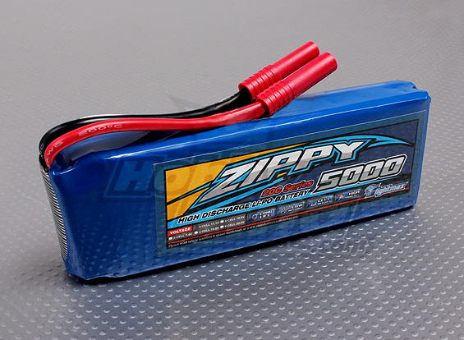

Figure 19. Zippy 5000 mAh 3S1P 20 C LiPo Battery

## 2.2.7. Beacon System

The beacon system is designed to drop two beacons. The system consists of a rack and pinion, four modified c-brackets, a servo motor, two LEDs, and fishing line. The rack and pinion was 3D-printed, and the pinion was attached to the servo motor. The lengths of the four c-clamps were made shorter with a band saw and sand belt. Two c-clamps were then connected together with epoxy. There is adequate room in between the c-clamps for the rack to slide through. The pinion sits between the two pairs of modified c-clamps. This set up can be seen in Figure 20.

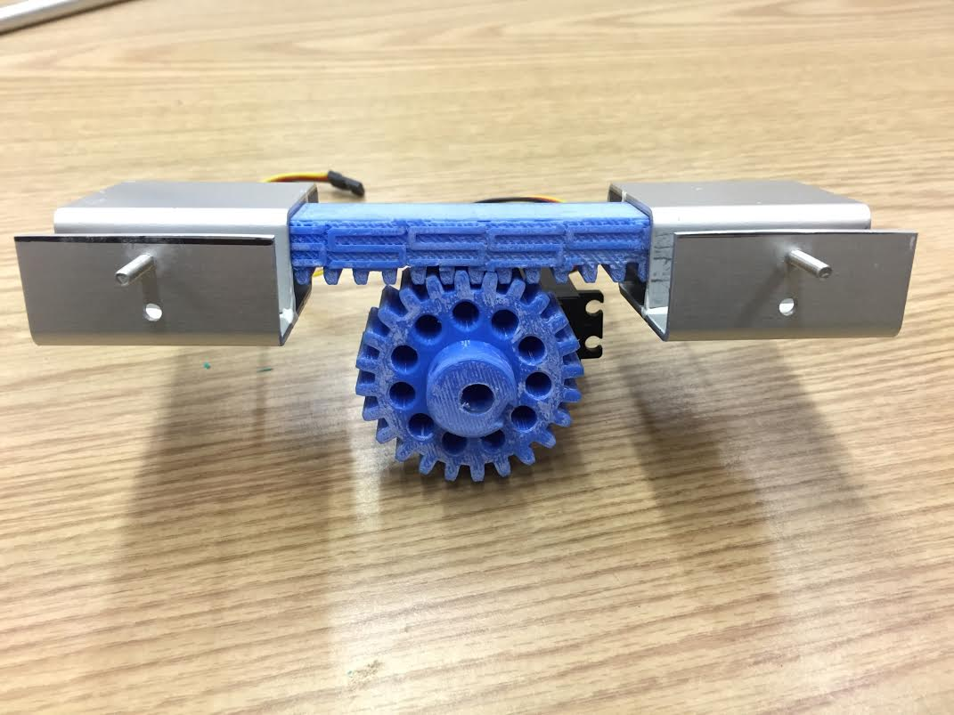

Figure 20. Beacon System

The idea is that there will be two beacons looped around the rack; one on each side of the pinion. The beacon consists of glow-stick attached to fishing line. When the rack rotates clockwise, one beacon will slide off and drop due to gravity; when the rack rotates counterclockwise, another beacon will drop.

## 2.2.8. Buoy

The buoy floats on the water surface and holds the router with an Ethernet cable running down to the UUV. The Ethernet cable connects to the Beaglebone, and with the router, data can be transmitted to the ground station. The buoy is made up of a rectangular piece of wood, two Styrofoam legs, and a plastic container. The router sits in the plastic container; three holes were drilled through the container for the two antennas and the Ethernet cable. The container sits on the wood, which is sitting on top of two Styrofoam legs. The buoy can be seen in Figure 21.

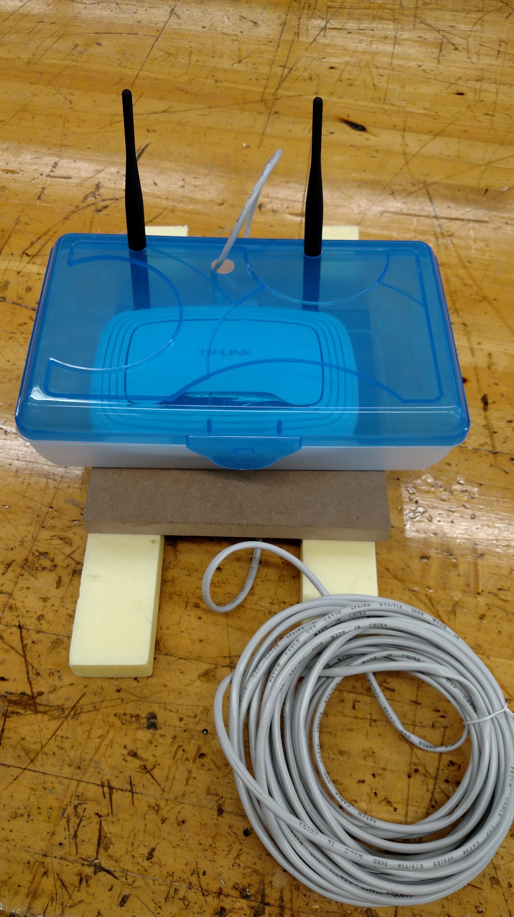

Figure 21. Buoy

## 2.3. Use

All operation of the UUV is performed from the ground station. The operator uses a keyboard to send inputs to the UUV. The inputs will control both the propulsion and ballast systems to navigate the UUV. Additionally, the live camera feed will be displayed on the laptop to allow the operator to successfully navigate without crashing. Also all the sensor data will be displayed on the laptop to easily be read by the operator.

# 3. Implementation

There was no prototype for this project. We tested parts of our project as we went making the necessary modifications. One of the changes that was made was the design of the ballast system. The original design used hard walled ballast tanks and we are now using a flexible ballast tank. Other slight modifications were made as we worked on the project. The structure of the code used for controlling the UUV was changed. The overall length of the UUV was decreased to decrease the internal volume. This allowed less weight to be added to sink the UUV.

# 4.   Evaluation

## 4.1. Overview

For the 3D printed part of the design the parts were tested using 3D modeling software. Prototypes of the 3D printed parts were printed out and tested for water proof and strength. The final printed parts were tested without any of the electronic parts included. The mechanical engineers tested the physical parts. The 3D printed material was tested in water in the university’s pool. The electronic components were all tested individually. Putty and Eclipse were used to write programs on the BeagleBone that tested the different electrical components. The electrical engineers tested all of the electrical components. The computer engineers tested the code for the electrical components and interfaced with them through the ground station. The full test procedure for each part of the design is described in Appendix B.

## 4.2. Testing and Results

In Appendix B we list all of our test procedures. In this section we will go over the results of our tests.

WCP10 - 001: Run on only batteries. This test has passed. All of the components have been successfully powered by the battery.

WCP10 - 002: Run for 45 minutes on batteries. This test has passed. The system ran for more than 45 minutes on batteries.

WCP10 - 003: Work under 14 feet. This test has not passed. The ballast system is not functional at this time and therefore we could not test at 14 feet.

WCP10 - 004: 50% 3D-printed: This test has passed. As seen in Figure 22, a visual inspection shows that most of the UUV consists of 3D printed parts. The entire body of the UUV has been 3D-printed with the exception of the dome, the back plate, and the heat sink.

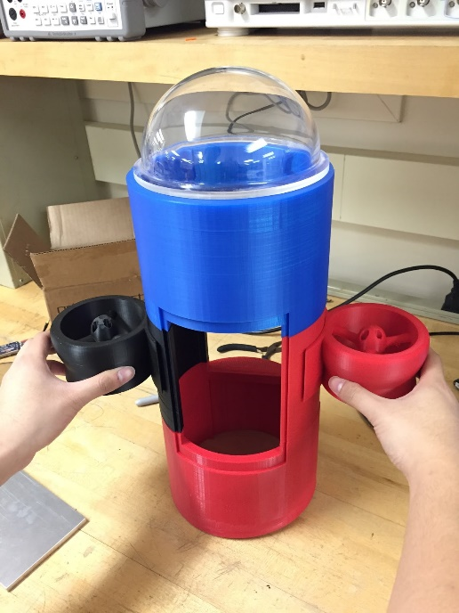

Figure 22. 3D Printed Parts of UUV

WCP10 - 005: Ballast system. This test has not passed. The pumps that we obtained with our budget were not sufficient in bringing in water to the water tanks.

WCP10 - 006: 4.0 knots speed. This test has not passed. According to our calculations the UUV should be able to travel at this speed. In practice the UUV did not travel in a straight path, therefore the speed was not easily measurable.

WCP10 - 007: 5 sensors. This test has passed. The sensors we are using are two temperature sensors, video camera, water leak, pressure/depth, low visibility navigation, and an IMU. These sensors are described and pictured in Section 2.2.2 (Figures 9-13).

WCP10 - 008: Real time transmission to ground station. This test has passed. The video stream, IMU data, and temperature data are accurately displayed on the ground station in real time.

WCP10 - 009: 50m transmission. This test has passed. The router has been tested with transmitting data for a distance greater than 50m. More than 50 meters were measured in the basement of the library, starting from the senior design lab down to the hallway. There was still transmission from 50+ meters and through walls and obstruction.

WCP10 - 010: Beacon system. This test has not passed. The beacon system is fully designed but has not been integrated.

WCP10 - 011: H.264 compression. This test has passed. The camera that is being used is the Logitech C920 HD webcam. This web camera uses full HD 1080p video streaming with built in H.264 compression.

WCP10 - 012: Navigate in low visibility environment. This test has not passed. The sonar is still in the testing phase. It has been determined that four of the five ICs (LM1812) that have been used for testing the 200kHz water ranging circuit have blown. This has been determined based upon the behavior on the output pin of the circuit (Figure J1).

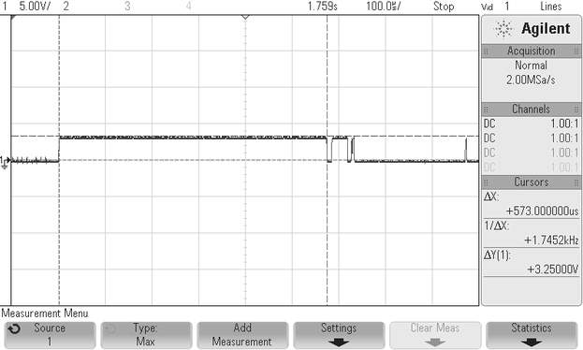

**Figure J1**

The typical behavior on the output is supposed to idle high, but when the blown circuits are triggered with a 200us pulse, they simply show what is displayed in Figure J1, which exceptional noise when the transducer’s shielding is not grounded. In Figure J2, we see a case of when the last working IC is pulsed. The image shows two sources, one of which is the output idling high, and then going low (not clearly visible against the oscillation) when triggered, before returning high. The oscillation is the transducer being triggered in air, which explains why the output does not go low on receiving a return echo.

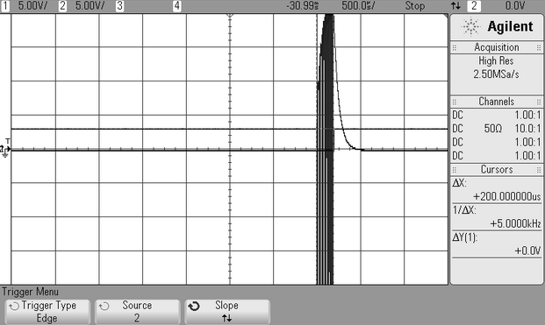

**Figure J2**

In Figure J3, it displays what happens when the circuit is triggered in a 3ft long container filled with water. It is clear that there is no measurement received, but a receiver delay on the circuit is supposed to be 1ms, set by a 100nF capacitor on pin 9 if the IC. It is obvious that with this in mind, the circuit should go low 1ms after the initial 200us pulse, even while the transducer is still being triggered, but it does not. The reasoning behind this can either be that the circuit never receives a return echo because the initial pulse to the transducer is too weak (~60Vpp), or the time delay on the receiver is not really 1ms. Another concern for me is that the oscillation to the transducer is centered at -5V as opposed to 0V, and then slowly returns to 0V after the one-shot from the IC.

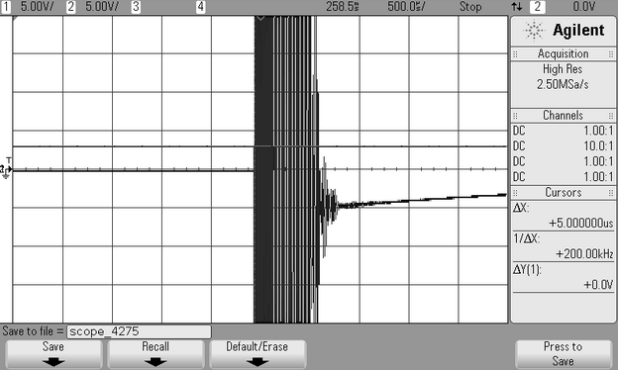

**Figure J3**

WCP10 - 013: Retrieve beacon. This test has not passed. This is an optional requirement.

WCP10 - 014: Ground station display video. This test has passed. The BeagleBone is using MJPG streamer to transmit the video stream.

WCP10 - 015: H.264 decompression. This test has passed. The video is viewable on the ground station so the data is decompressed.

WCP10 - 016: Ground station receiving data. This test has passed. The data sent from the router displays on the ground station via a web browser. This can be seen in Figure 23.

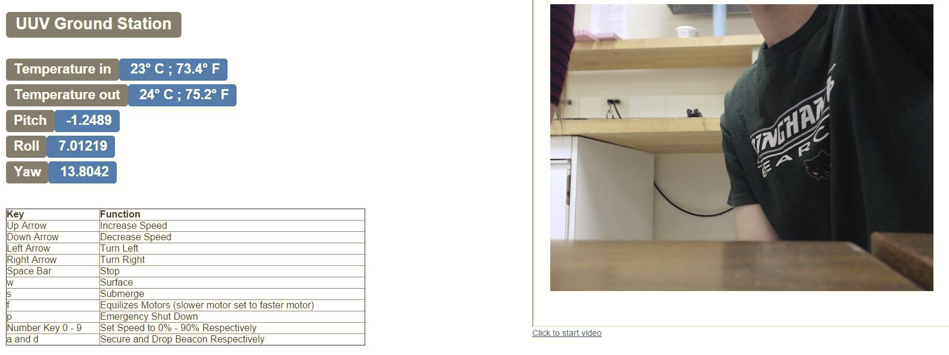

Figure 23. Data Received via Web Browser

WCP10 - 017: Depth sensor. This test has not passed. The depth sensor is still in testing.

WCP10 - 018: IMU sensor. This test has passed. Pitch, roll, and yaw data have been collected from the IMU and can be seen in Figure 23.

WCP10 - 019: Temperature sensor. This test has passed. Data has been collected from the two different temperature sensors at the same time and can be seen in Figure 23.

WCP10 - 020: Water leak sensor. This test has passed. Water can be detected. In Figure 24a, it can be seen that when the water leak sensor is in air the processor detects a logic high, verifying that there is no water. In Figure 24b, it can be seen that the processor detects a logic low when dipped into water, confirming that the wire is capable of being used to detect water.

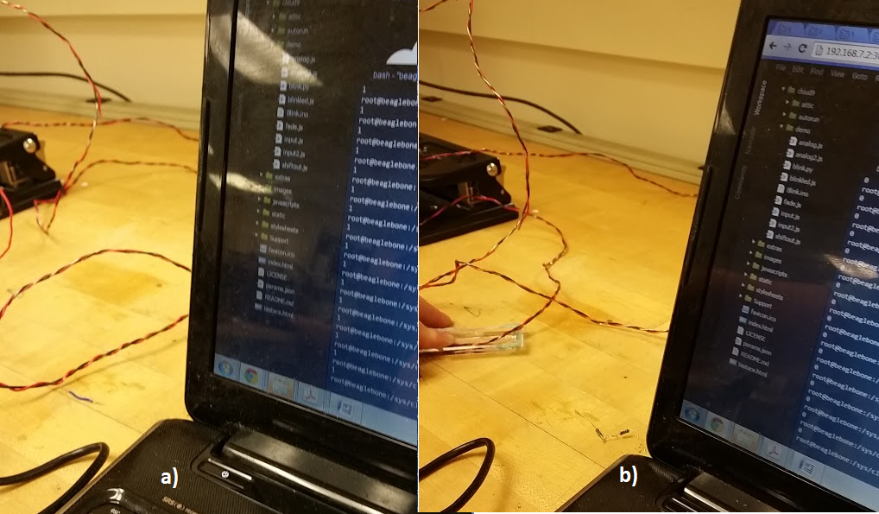

Figure 24. Water Leak Sensor Data

WCP10 - 021: Low visibility environment sensor. This test has not passed. Please refer to requirement 12.

WCP10 - 022: Video camera. This test has passed. Data from the video camera can be processed and transmitted using the BeagleBone. This video stream can be seen in Figure 23.

WCP10 - 023: Fresh water. This test has passed. All of the components have been tested in fresh water. Epoxy and waterproof silicone were used on the surface of the UUV as a sealant. The epoxy and silicone are designed for marine application, and the materials of all of our components (PLA, steel, acrylic) do not deform underwater.

WCP10 - 024: $800 budget. This test has passed. The budget chart in Section 5 shows that our total spending has not exceeded the budget allocated to our team.

WCP10 - 025: $600 team budget. This test has passed. The project has not used any of the team budget.

WCP10 - 026: User Manual. This test has passed. The user manual has been written.

## 4.3. Assessment

Currently, most of the subsystems of the UUV are working separately, but tasks remain in accomplishing full system integration.

### 4.3.1 Mechanical Engineering

In terms of the mechanical design, all aspects except for one were successful. The overall design itself is hydrodynamic. Using Creo Parametric 2.0, a visual representation of the UUV was created, and these files were converted for 3D printing. The exact mass and dimension of every component was found using Creo. More than half the structure was 3D printed, and there was adequate space for all interior components. Calculations concerning the fluid mechanics and physics of the UUV were used to aid the final design. MATLAB code was used to calculate the buoyancy as seen in Appendix C. Waterproof testing was also performed to ensure the safety of the structure; none of the electronics should touch water. Many of the components were personally manufactured in the University’s Machine Shop. These components include the electronics compartment, acrylic cap, landing gear, hatch, beacon system, and parts of the ballast system.

The one failure experienced by the mechanical team was the ballast system. Although the ballast system should have worked in theory, it did not since the pumps were incompatible with the project parameters. If a high power pump was purchased, then the ballast system would have worked. Due to budget limitations, the stronger pumps would have exceeded the team budget.

If there was another opportunity to do the project again, then two aspects would be reconsidered. The first aspect would be the hatch design of the UUV. Instead of using a gasket, an o-ring would be implemented. The gasket did not create the tight seal desired, so waterproof duct tape was used. The second aspect would be the ballast system. If there was a greater budget, then a piston-ballast system could be implemented instead.

The most important lesson learned throughout this project was about the limitations of 3D printing. Although 3D printing provides great opportunity for prototyping and open creativity, there are technical issues associated with it. For example, parts can fail midway through the print, or they can curl when they are done printing. Parts do not print with high accuracy, so the assembly process becomes difficult. In addition, the time consumption of 3D printing is very high, which limits the schedule. Lastly, the honeycomb structure of 3D printed parts makes waterproofing a very difficult task.

### 4.3.2 Electrical Engineering

The Electrical Engineering task was sensors and power management. The electrical architecture of the UUV was not integrated early enough to allow sufficient testing and debugging for proper functionality. In the end, it was more important to ensure that the UUV could be mobile in the water rather than integrate many of the sensors and electronics. The power protection circuitry worked alone, but when put into the full electrical system there was an issue in obtaining a full system shutdown. It would have been a great opportunity to fully test our UUV in deep water without worrying if structural failure would destroy all of our electronics. The water leak sensor was working, but it was not considerable in our test run. It would have been a good tool in giving the user a way to know when to pull the UUV out of the water in case of a leak, as well as beneficial alongside the power protection to shut down the system. The sonar sensor, which would have been used to obtain a distance measurement from the front of the UUV, did not work. Based on the cost and risk of other options it seemed best to make an attempt to design it, but in the end the design could not meet our requirement to aid in low visibility environments.

The propulsion system utilized the brushless outrunner motor. The design of the motor allows it to operate underwater naturally without any effect on its performance. It also provides high torque and power to generate enough thrust incorporated with the 3D printed propeller. The motor also requires almost zero maintenance. The propeller was designed specifically for the outrunner motor. Its dimension was determined by the OpenProp software to ensure that the propeller’s diameter and pitch would deliver the desired power. The 3D printing of the propeller allowed us to quickly prototype and replace the propeller if it is necessary. The last advantage of the propulsion system is the low cost as compared to other sophisticated designs. However, the motor does not have any encoding devices to acknowledge its rotation speed and position to the control board.

The Inertial Measurement Unit (IMU) was used to determine the pitch, roll, and yaw of the UUV. The IC chip is MPU-9250 which integrated accelerometer, gyroscope, and magnetometer to send the data to the control board via I2C communication protocol. The IMU does not only tell the orientation of the UUV but it can be incorporated to the motor control scheme (e.g PID) for better handling of the UUV underwater. Also the depth sensor was integrated to indicate the depth to the UUV and could be also be integrated with the ballast system for more sophisticated depth control.

If the team is given another opportunity to re-work on the project, there should be more testing and various designs to be achieved for better UUV handling.

### 4.3.3 Computer Engineering

The major Computer Engineering task was Ethernet Communication. For the most part this was a complete success. We successfully communicated data from the UUV to a webpage via a wireless router. Specifically, we transmitted a live HD video stream with minimal lag (about 0.5 seconds), readings from two different temperature sensors, and an IMU that supplied pitch, roll, and yaw. The webpage layout was also designed to our liking. Additionally, we successfully transmitted data from the ground station to the UUV. Specifically, we were able to independently control two different motors via electronic speed controllers. The motors are controlled on the ground station by using a keyboard.

There are some areas for improvement for this part. First, the video stream does not start automatically on the webpage. A link must be clicked to view the video stream. Second, there are a decent amount of separate scripts that must be run to set up the UUV. Each motor has two scripts, the ground station webpage has a script, and the motor control has a script. Third, the PWM pin set up is not saved when the Beaglebone is powered off. That is why there are two scripts per motor. Fourth, sometimes the file name for the PWM control changes, and there are multiple locations in our code that must be updated accordingly. Lastly, the ground station can be improved by being able to control the motors through the webpage itself instead of the terminal window

# 5. Schedule and Budget

|  |  |  |  |  |  |
| --- | --- | --- | --- | --- | --- |
| **Item** | **Quantity** | **Original Estimate ($)** | **Actual to Date ($)** | **Estimate to Completion ($)** | **Estimate at Completion ($)** |
| PLA | 2 | 0 | 96.00 | 96.00 | 96.00 |
| Acetone | 1 | 7.00 | 7.48 | 7.48 | 7.48 |
| Acrylic Dome | 1 | 30.00 | 40.50 | 40.50 | 40.50 |
| Marine Epoxy | 3 | 20.00 | 14.94 | 14.94 | 14.94 |
| Waterproof Sealant | 1 | 5.00 | 4.28 | 4.28 | 4.28 |
| Water Pump | 4 | 80.00 | 47.52 | 47.52 | 47.52 |
| H-bridge | 2 | 0 | 0 | 0 | 0 |
| Electronic Speed Controller | 2 | 30.00 | 23.34 | 23.34 | 23.34 |
| Brushless Motor | 2 | 30.00 | 33.00 | 33.00 | 33.00 |
| Propeller (3D print) | 2 | 0 | 0 | 0 | 0 |
| Beaglebone Black | 1 | 51.99 | 51.99 | 51.99 | 51.99 |
| IMU | 1 | 20.00 | 27.50 | 27.50 | 27.50 |
| Water Leak Sensor | 1 | 0 | 0 | 0 | 0 |
| Temperature Sensor | 2 | 5.00 | 7.81 | 7.81 | 7.81 |
| Sonar Sensor | 1 | 80.00 | 38.60 | 38.60 | 38.60 |
| Depth Sensor | 1 | 20.00 | 27.40 | 27.40 | 27.40 |
| Battery Protection Circuit | 1 | 8.00 | 4.42 | 4.42 | 4.42 |
| Wireless Router | 1 | 30.00 | 19.99 | 19.99 | 19.99 |
| 30 ft. Ethernet Cable | 1 | 10.00 | 6.99 | 6.99 | 6.99 |
| Servo | 1 | 0 | 0 | 0 | 0 |
| Camera | 1 | 60.00 | 53.99 | 53.99 | 53.99 |
| LiPo Battery | 2 | 50.00 | 39.98 | 39.98 | 39.98 |
| Battery Charger | 1 | 25.00 | 30.78 | 30.78 | 30.78 |
| Miscellaneous | N/A | 80.00 | 69.55 | 69.55 | 69.55 |
| Shipping | N/A | 20.00 | 17.03 | 17.03 | 17.03 |
| **Total** |  | **652.99** | **663.09** | **663.09** | **663.09** |

Table 1. Project Budget

|  |  |  |
| --- | --- | --- |
| **Description** | **Percent Completed** | **Date Completed** |
| Project Launch | 100 | 09/24/2014 |
| Specifications | 100 | 10/17/2014 |
| Development Plan | 100 | 10/31/2014 |
| Architectural Presentation | 100 | 11/14/2014 |
| Interim Report | 100 | 12/05/2014 |
| Interim Presentation | 100 | 12/12/2014 |
| Midterm Report | 100 | 04/03/2015 |
| Full Integration and Testing | 70 |  |
| Final Presentation |  |  |
| Experience Video |  |  |

Table 2. Project Schedule

# 6.   Next Steps

The next step is to give the project to Lockheed Martin. They will use the project as they see fit. This could include using it for underwater navigation, recreational purposes, or educational demonstrations. Additional work that could be done is implement a beacon retrieval system, grant easier access to the inside of the UUV, and upgrade parts to a higher quality alternative. For example, a stronger ballast pump or propeller motor. Lockheed Martin should assign personnel to work on additional improvements to the UUV at their discretion. The UUV and instruction manual will be delivered to Lockheed Martin at a time after our presentation in person.

# 7.   References

[1] D. W. French, “Analysis of Unmanned Undersea Vehicle (UUV) Architectures and an Assessment of UUV integration into Undersea Applications,” M.S. Thesis, Dept. Systems Eng., Naval Postgraduate School, Monterey, CA, 2010.

# Appendix A Requirements

|  |  |
| --- | --- |
| **System Requirement** | **Description** |
| **WCP10-001** | The UUV shall run on batteries and not require any external power source. |
| **WCP10-002** | The UUV shall operate for a minimum of 45 minutes on a single battery charge. |
| **WCP10-003** | The UUV shall be able to travel to a depth of at least 14 feet. |
| **WCP10-004** | At least 50% (rough estimate) of the structure of the UUV shall be 3D printed. |
| **WCP10-005** | A ballast system shall control the depth of the UUV. |
| **WCP10-006** | The UUV shall be able to run at least 4 knots. |
| **WCP10-007** | The UUV shall contain at least 5 sensors. |
| **WCP10-008** | Video stream(s), sensor data, and other data pertinent to the UUV shall be transmitted to the ground station in real time. |
| **WCP10-009** | The UUV shall transmit wirelessly to a ground station at least 50 meters away. |
| **WCP10-010** | UUV shall be able to locate a previous location via beacon system. |
| **WCP10-011** | Video stream shall use H.264 compression. |
| **WCP10-012** | UUV shall be able to navigate in low visibility environment. |
| **WCP10-013** | UUV should be able to retrieve the beacon underwater. |

|  |  |
| --- | --- |
| **External Requirements** | **Description** |
| **WCP10-014** | The ground station shall be able to display video from the UUV. |
| **WCP10-015** | Video stream shall use H.264 decompression. |
| **WCP10-016** | The ground station shall receive data from the UUV from at least 50m away. |

|  |  |
| --- | --- |
| **Internal Requirements** | **Sensor** |
| **WCP10-017** | Depth |
| **WCP10-018** | IMU |
| **WCP10-019** | Temperature |
| **WCP10-020** | Water Leak |
| **WCP10-021** | Low Visibility Navigation |
| **WCP10-022** | Video Camera |

|  |  |
| --- | --- |
| **Environment Requirement** | **Description** |
| **WCP10-023** | The UUV shall operate in freshwater. |

|  |  |
| --- | --- |
| **Design and Construction Constraints** | **Description** |
| **WCP10-024** | There shall be a Lockheed Martin budget of $800 for major components of the system. |
| **WCP10-025** | There shall be a team budget of $600 for minor components of the system. |

|  |  |
| --- | --- |
| **Other System Requirements** | **Description** |
| **WCP10-026** | Create a user manual for UUV operation and handling. |

# Appendix B Test Procedures

Requirement

**The UUV shall run on batteries and not require any external power source. {WCP10 - 001}**

Equipment

1. Batteries
2. Electronic components of the UUV
3. Ground station computer

Procedure

1. Connect all the electronics to batteries.
2. Turn on the power switch.
3. Ensure all electronics are powered by the batteries, and functional.
4. Check that the ground station displays values for all of the sensors and the video stream the components are working.
5. Check that the motors, servo and water pumps can be controlled by the ground station.

Requirement

**The UUV shall operate for a minimum of 45 minutes on a single battery charge. {WCP10 - 002}**

Equipment

1. Batteries
2. Electronic components of the UUV
3. UUV
4. Pool
5. Ground station computer
6. Buoy

Procedure

1. Connect all the electronics to batteries.
2. Turn on the power switch.
3. Place the UUV in the pool.
4. Record time.
5. Operate the UUV for 45 minutes (based on recorded time), using the ground station to control it.

Requirement

**The UUV shall be able to travel to a depth of at least 14 feet. {WCP10 - 003}**

Equipment

1. UUV
2. Pool
3. Ground Station
4. Buoy

Procedure

1. Turn on the UUV.
2. Place UUV in the water.
3. Using the ground station send signals to the ballast system to sink the UUV.
4. Monitor the depth of the UUV on the ground station to determine when 14 feet is reached.

Requirement

**At least 50% (rough estimate) of the structure of the UUV shall be 3D printed. {WCP10 - 004}**

Equipment

1. UUV

Procedure

1. Observe the UUV to determine if 50% of the body is 3D printed.

Requirement

**A ballast system shall control the depth of the UUV. {WCP10 - 005}**

Equipment

1. UUV
2. Pool
3. Ground Station
4. Buoy

Procedure

1. Turn on the UUV.
2. Place UUV in the water.
3. Using the ground station send signals to the ballast system to sink/surface the UUV.

Requirement

**The UUV shall be able to run at least 4 knots. {WCP10 - 006}**

Equipment

1. UUV
2. Pool
3. Ground Station
4. Buoy
5. Tape measure
6. Video camera

Procedure

1. Turn on the UUV.
2. Place the UUV in the pool.
3. Place tape measure along the entire length of the pool.
4. Video tape the UUV going in a straight line along the edge of the pool.
5. Analyze the video to determine how far the UUV traveled in a given amount of time.
6. Convert this distance per second into knots.

Requirement

**The UUV shall contain at least 5 sensors.{WCP10 - 007}**

Equipment

1. Sensors

Procedure

1. Count sensors.

Requirement

**Video stream(s), sensor data, and other data pertinent to the UUV shall be transmitted to the ground station in real time. {WCP10 - 008}**

Equipment

1. Electronic components
2. Router
3. Ground Station

Procedure

1. Turn on all of the electronic components.
2. Run the programs associated with video stream and data transmission.
3. Open the web browser pages created by the programs to display data.
4. Ensure that the data is displayed on the ground station and that the video displays in real time.

Requirement

**The UUV shall transmit wirelessly to a ground station at least 50 meters away. {WCP10-009}**

Equipment

1. BeagleBone Black
2. Router
3. Ground station computer
4. Tape measure

Procedure

1. Turn on all of the electronic components.
2. Measure out 50 meters and place router 50 meters away from ground station.
3. Ensure that the ground station is displaying constantly updating data.

Requirement

**UUV shall be able to locate a previous location via beacon system. {WCP10-010}**

Equipment

1. Beacon
2. Pool
3. UUV
4. Ground station
5. buoy

Procedure

1. Navigate the UUV and drop the beacon into the desired location of the pool
2. Search and locate the position of the beacon in the pool through the camera in UUV

Requirement

**Video stream shall use H.264 compression. {WCP10 - 011}**

Equipment

1. Camera data sheet

Procedure

1. Check data sheet of camera to ensure that camera uses H.264 compression.

Requirement

**UUV shall be able to navigate in low visibility environment. {WCP10 - 012}**

Equipment

1. UUV
2. Ground station
3. Buoy
4. Pool

Procedure

1. Turn on UUV.
2. View data values of sonar system in the ground station.
3. Use this data to navigate in pool with lights off.

Requirement

**UUV should be able to retrieve the beacon underwater.{WCP10 - 013}**

Equipment

1. UUV
2. Beacon
3. Buoy
4. Ground station

Procedure

1. Turn on the UUV.
2. Navigate to the location of the Beacon.
3. Pick up beacon.

Requirement

**The ground station shall be able to display video from the UUV. {WCP10 - 014}**

Equipment

1. UUV
2. Buoy
3. Ground station

Procedure

1. Turn on UUV.
2. Run programs needed for the camera on the ground station.
3. Open the web browser.
4. Ensure you can view a video stream.

Requirement

**Video stream shall use H.264 decompression. {WCP10 - 015}**

Equipment

1. Camera data sheet

Procedure

1. Check data sheet of camera to ensure that camera uses H.264 decompression.

Requirement

**The ground station shall receive data from the UUV from at least 50m away.{WCP10 - 016}**

Equipment

1. BeagleBone Black
2. Router
3. Ground station computer
4. Tape measure

Procedure

1. Turn on all of the electron components.
2. Measure out 50 meters and place router 50 meters away from ground station.
3. Ensure that the ground station is displaying constantly updating data.

Requirement

**Depth {WCP10 - 017}**

Equipment

1. Depth sensor
2. Ground station
3. BeagleBone Black

Procedure

1. Plug Depth sensor into BeagleBone Black and BeagleBone into ground station.
2. Run code associated with Depth sensor.
3. Ensure that data received is correct.

Requirement

**IMU {WCP10 - 018}**

Equipment

1. IMU sensor
2. Ground station
3. BeagleBone Black

Procedure

1. Plug IMU sensor into BeagleBone Black and BeagleBone into ground station.
2. Run code associated with IMU sensor.
3. Ensure that data received is correct.

Requirement

**Temperature {WCP10 - 019}**

Equipment

1. Temperature sensor
2. Ground station
3. BeagleBone Black

Procedure

1. Plug Temperature sensor into BeagleBone Black and BeagleBone into ground station.
2. Run code associated with Temperature sensor.
3. Ensure that data received is correct.

Requirement

**Water Leak {WCP10 - 020}**

Equipment

1. Water leak circuit
2. Ground station
3. BeagleBone Black

Procedure

1. Plug water leak sensor into BeagleBone Black and BeagleBone into ground station.
2. Run code associated with water leak sensor.
3. Attach two probes together through water.
4. Ensure that the circuit powers off all electronics.

Requirement

**Low Visibility Navigation {WCP10 - 021}**

Equipment

1. Sonar sensor
2. Ground station
3. BeagleBone Black

Procedure

1. Plug Sonar sensor into BeagleBone Black and BeagleBone into ground station.
2. Run code associated with Sonar sensor.
3. Ensure that data received is correct.

Requirement

**Video Camera {WCP10 - 022}**

Equipment

1. Camera
2. Ground station
3. BeagleBone Black

Procedure

1. Plug camera into BeagleBone Black and BeagleBone into ground station.
2. Run code associated with camera.
3. Open web browser to view video stream.

Requirement

**The UUV shall operate in freshwater. {WCP10 - 023}**

Equipment

1. UUV

Procedure

1. UUV is designed for freshwater so ensure all tests are done in freshwater.

Requirement

**There shall be a Lockheed Martin budget of $800 for major components of the system. {WCP10 - 024}**

Equipment

1. Budget sheet

Procedure

1. Verify that Lockheed Martin budget of $800 is allocated to the major components of the system in the budget sheet.

Requirement

**There shall be a team budget of $600 for minor components of the system. {WCP10 - 025}**

Equipment

1. Budget sheet

Procedure

1. Verify that team budget of $600 is allocated to the minor components of the system in the budget sheet.

Requirement

**Create a user manual for UUV operation and handling. {WCP10 - 026}**

Equipment

1. Computer with Microsoft Word

Procedure

1. Construct the user manual into a word document.

# Appendix C UUV Program and Code

All the programs and code are available for access from the link below:

https://github.com/Junle-Lu/BeagleUUV

# Appendix D Creo Drawings and Analysis

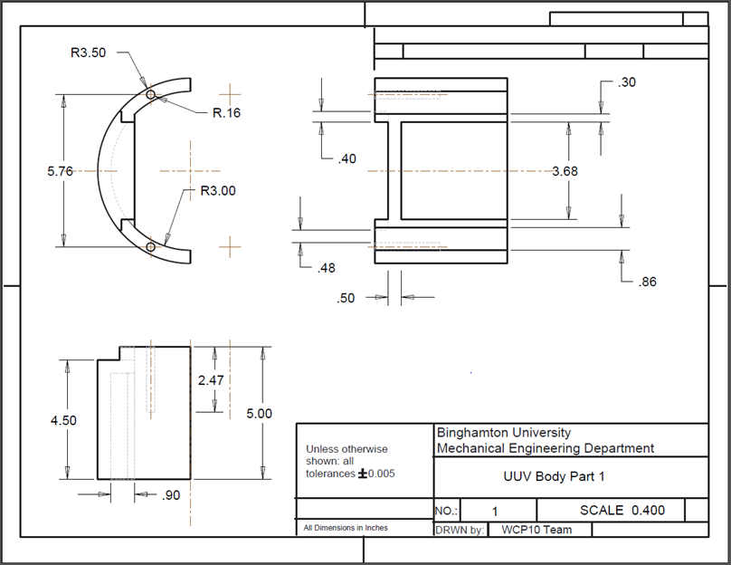

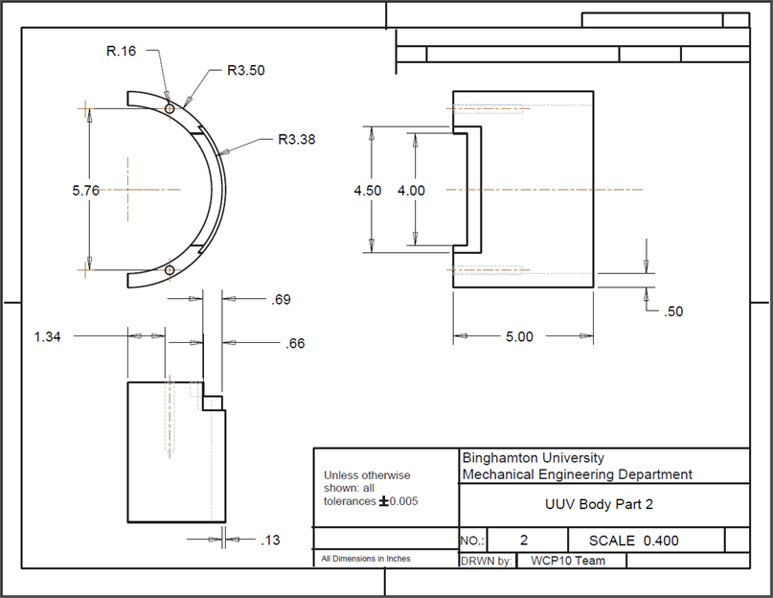

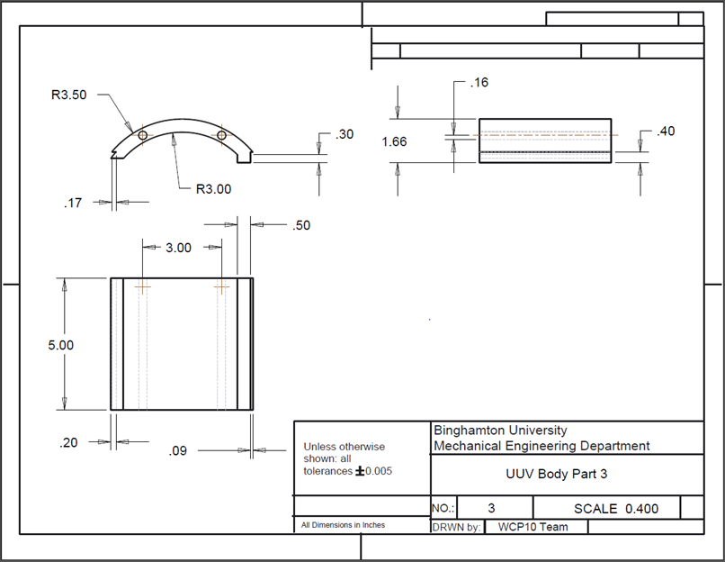

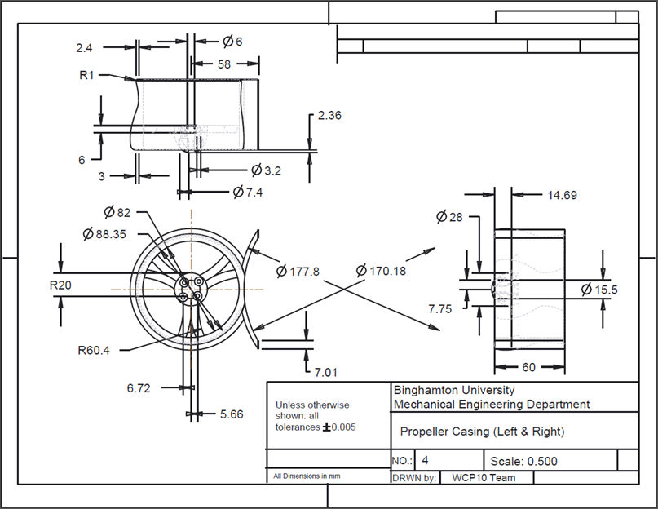

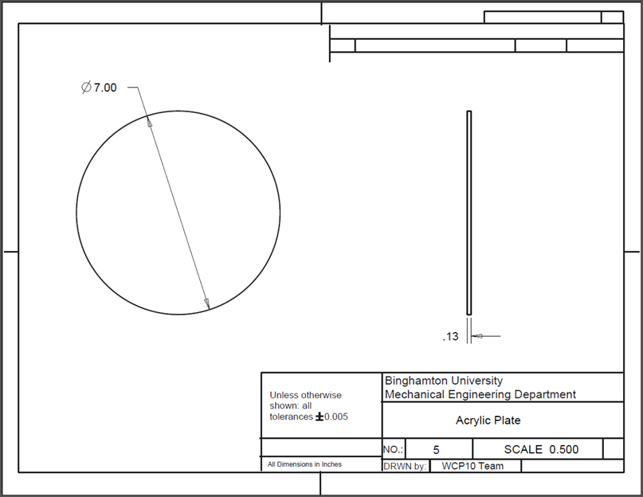

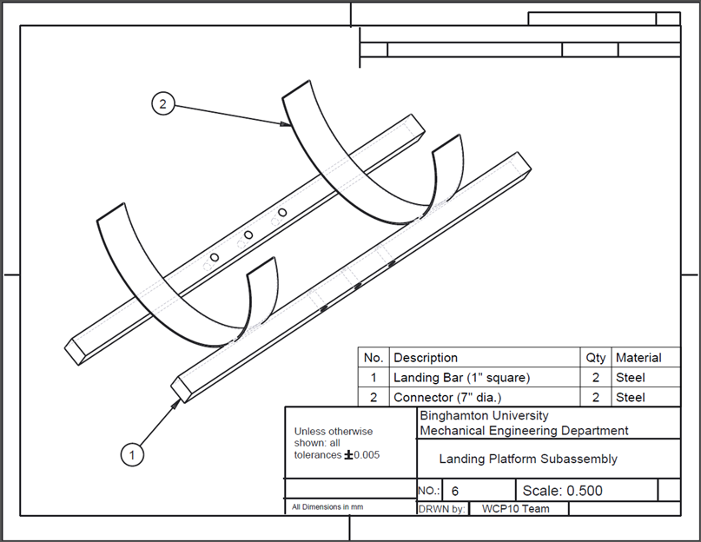

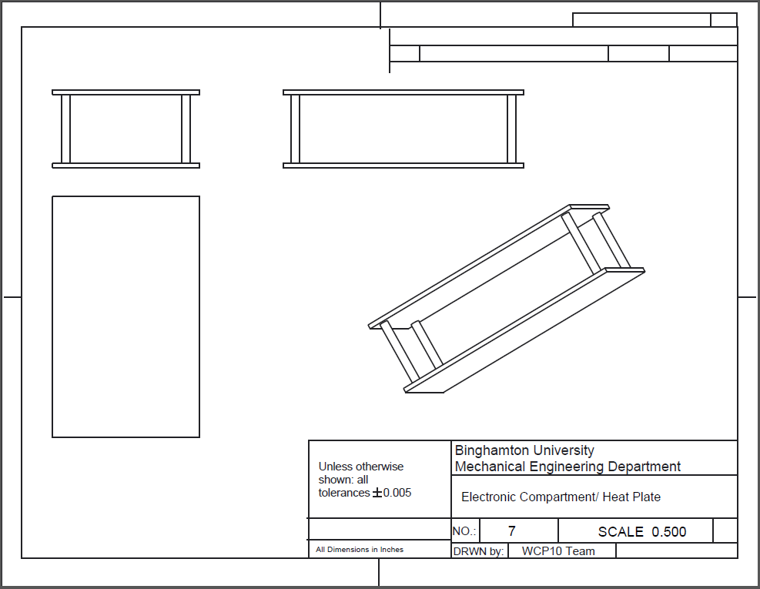

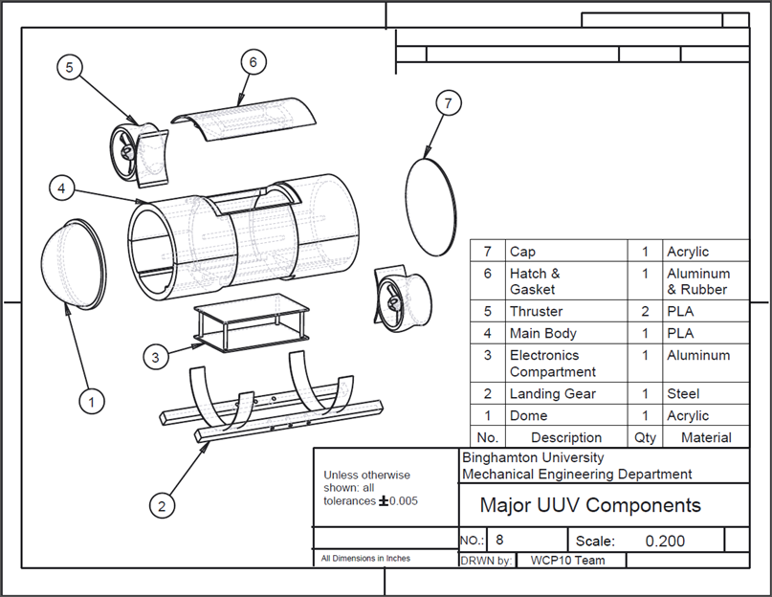

**Finite Element Analysis**

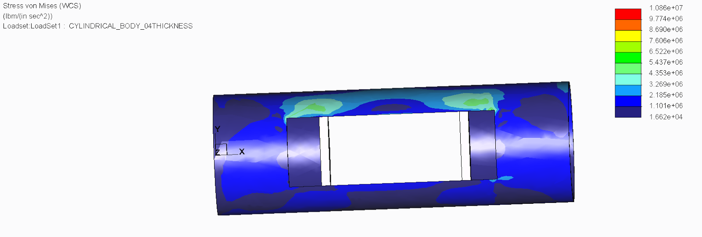

Cylindrical Body with 0.2 inch Thickness

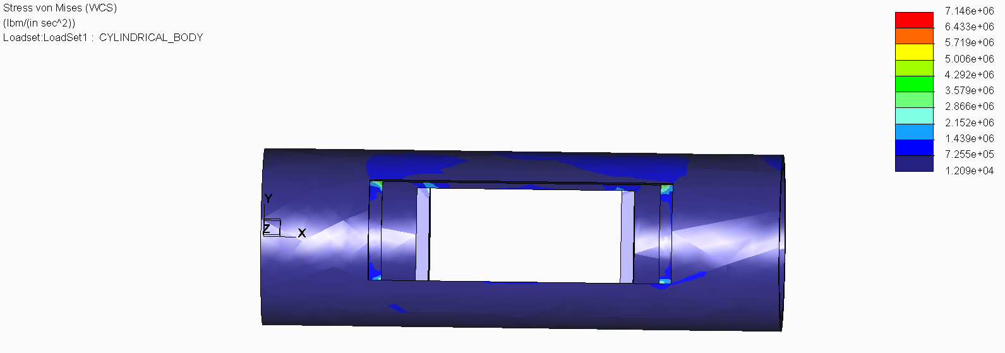

Cylindrical Body with 0.5 inch Thickness

# Appendix E Data Sheet Links

Some of the parts that we are using have very long data sheets so we are adding links to the data sheets instead of the actual data sheets.

Wireless Router Model number TL-WR841N:

<http://www.tp-link.com/Resources/document/TL-WR841N_V8_User_Guide.pdf>

BeagleBone Black:

<http://www.adafruit.com/datasheets/BBB_SRM.pdf>

DS18B20 Temperature Sensor:

<http://datasheets.maximintegrated.com/en/ds/DS18B20.pdf>

MPU-9250 9 Axis Sensor:

<http://invensense.com/mems/gyro/documents/PS-MPU-9250A-01.pdf>

MS5637 Pressure Sensor:

<http://www.meas-spec.com/downloads/MS5637-02BA03.pdf>

NTM Prop Drive Series 2836:

<http://www.hobbyking.com/hobbyking/store/__19611__NTM_Prop_Drive_28_36_750KV_265W.html>

# Appendix F Sensor Circuit Diagrams

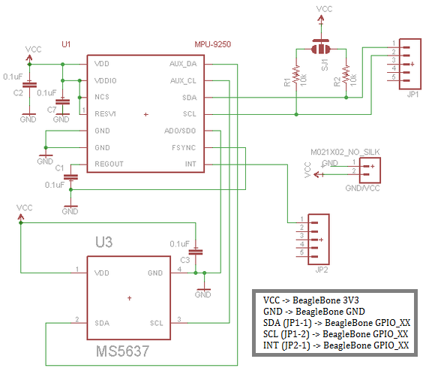

F.1: IMU/Pressure Sensor Circuit Diagram

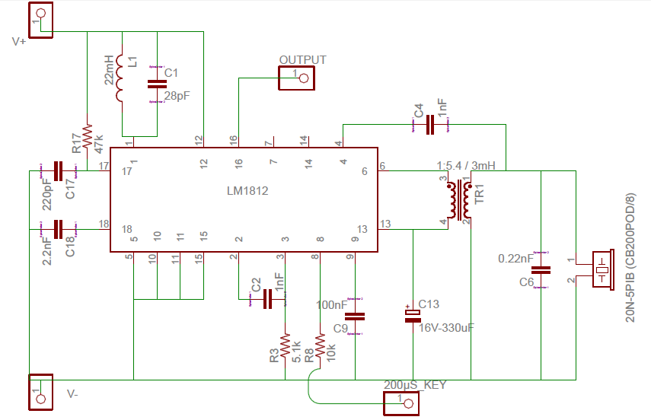

F.2: Sonar Transducer Circuit

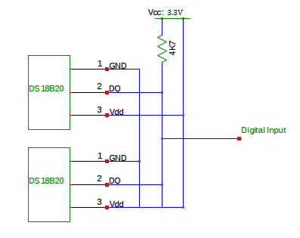

F.3: Temperature Sensor Circuit

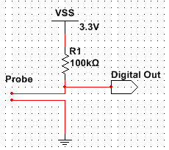

F.4: Water Leak Sensor

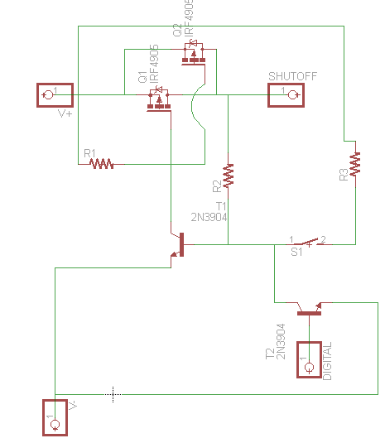

F.5: Battery Shutdown Circuit